cobas c 111

Final Review

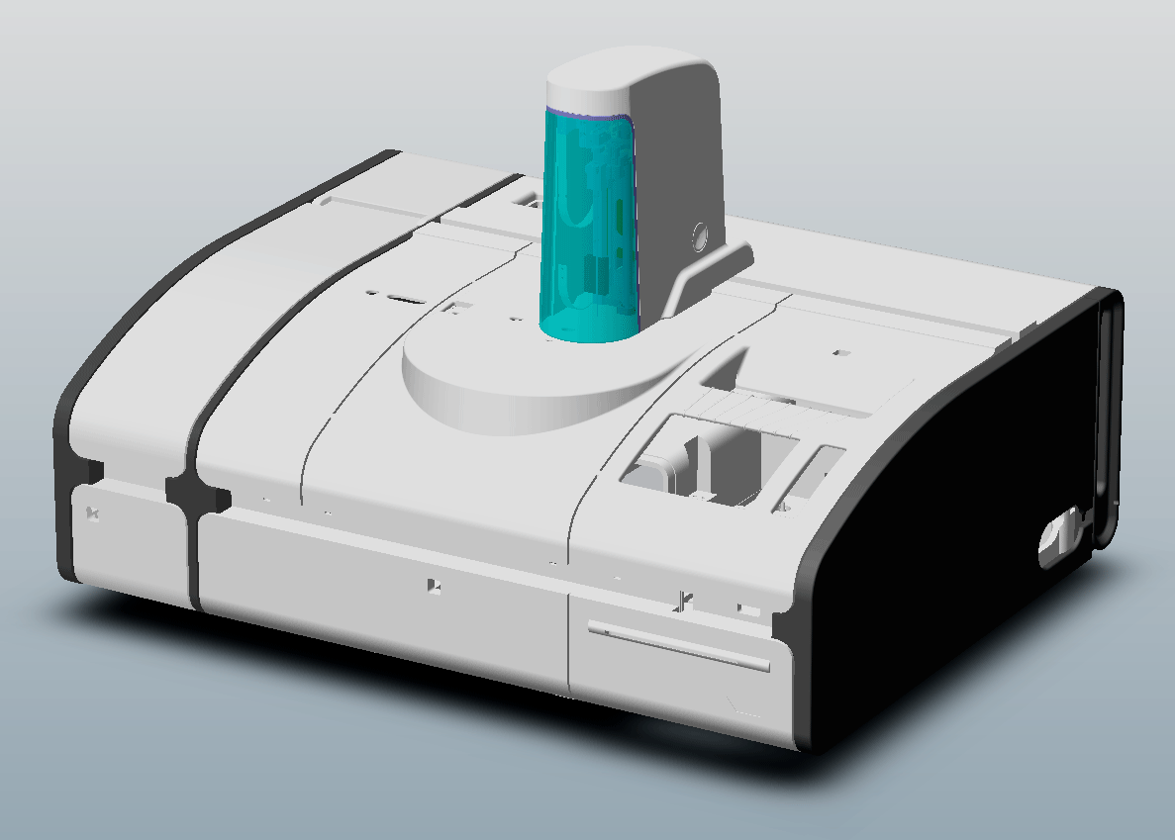

Version 1.1
Name: ___________________________________________ Date: _____________________

About this final review:

With this final review you should check yourself, how this training course has helped you and which information we could give you. In addition you have now a short reference with the most important basics.

On the other hand this final review is a good feedback for the trainers on which part of the training course we have to improve or to consolidate, because you should profit optimally from the service training course.

Please answer the following questions:
-  means with a clear cross  or a big point 

If it is not written something else, only one answer for the multiple choice questions is correct.

If it is written, more than 1 answer is correct, you should have all answers correct marked for getting the maximum points of this question. If there is something correct marked, but not everything, you will get the half of the maximum points. If you marked everything wrong, you will get zero points for this question.

Of course you can use all sources, like manuals, eSDoc or own notices for this final review but excluding your neighbors.

If it is not explicit written, all questions are referring to the cobas c 111.

If you don’t understand a question, please do not hesitate to ask the trainer.

The result of this final review will not be communicated to your country organization. It should be helpful for you and also for us trainers to see where still gaps in the knowledge are.

You will get later on the whole final review including the correct answers.

Please don’t forget to fill out the top of this page.

Your Score: ____- _83_ / Points

Group Average: _________ / Points

Reviewer: _____________________________

Fluidic System

- 2 Points  How is the cleaner transported to the probe? |  Waste Pump P2   Syringe   Wash Pump P1   Syringe and Wash Pump P1, depends on Fluid Operation

- 3 Points  The liquid level in the Waste container is monitored…. |  Using a Liquid sensor   Visual, by the Operator   Using a floater Switch   Using a inductive sensor

- 2 Points  The ISE waste liquid is transported directly into the… |  Waste Container   Wash Station   Internal Waste Tank   External liquid reservoir

- 2 Points  When is the Transfer Head Fluid Sensor initialized? |  Manually with a Maintenance Action   During the yearly Maintenance   When Instrument status changes from Standby to Operating   During start-up

- 2 Points  How do you adjust the Degasser Fluid Sensor? |  Is automatically adjusted during init   Does not need adjustment   Diagnostics SW function   Maintenance SW function

Transport System

- 2 Points  On which PCB is the LLD Basic level frequency generated? |  PCB Main board   PCB Base module   PCB Transfer Head   PCB Connector

- 4 Points  X and Z Transfer zero positions are detected using….. |  Initialisation plate   Light barrier for Z Mechanical stop for X   Light barriers only   Mechanical stops only

- 3 Points  What type of motors are used for X and Z |  24V step motors   24VDC motors   36V step motors   for X step motors and for Z DC motors
- 3 Points  How do you adjust the X-Belt tension? |  With internal spring-loaded pulley   With Belt Tension Tool   Diagnostics SW function   Does not need adjustment

Electronic System

- 2 Points  On which PCB(s) is (are) 5V generated |  Mainboard   Base Board, Mainboard, ISE Control, ABS Supply, Connector   ABS Supply, ISE Control, Mainboard, Base Board CPU   Mainboard ISE Control

- 2 Points  The Powerbox provides the instrument with which voltages? |  Only +24V   Only +15V, -15, +5V and +24V   Only +15V, -15V, +5V, +24V and 3.3V   Only +15V, -15V, +5V and +24V

- 2 Points  Where is the Real-Time CPU located? |  PCB Mainboard   PCB RT-CPU   PCB Base Board   PCB Power Supply

Measurement System

- 2 Points  How many different wavelengths does the ABS photometer use? |  1   2   12   8

- 2 Points  Where are the ABS control circuits located? |  Inside the ABS Photometer   On the PCB Mainboard   On the PCB Base Board

- 2 Points  When do you have to replace the ABS Halogen Lamp? |  When instrument tells you do so.   Every 6 months (Maintenance SW function)   Both of the above

- 2 Points  How is the light intensity adjusted? |  With the current   With the voltage   Both of the above   No light intensity adjustment necessary

- 2 Points  How do you perform the ABS Air/Water Calibration? |  Sample order with Check Sample   Calibration is done automatically after Instrument installation or Lamp replacement   Diagnostics SW function   Maintenance SW Function

- 2 Points  When are the cuvettes checked for optical specification conformity? |  During “Air / Water Calibration”   Operator has to check visually   When switching from Standby to Operating   In machine cycle 1 of each test run

Sample System

- 2 Points  How are the sample tubes detected? |  Flags in a light barrier   Reflection light barrier detects tube   No HW-Detection, only monitored by SW

- 2 Points  When are you allowed to load a sample tube? |  During standby only   Just before I press the start button   When the green LED next to the sample area is lit

Reagent System

- 2 Points  How does the c111 identify the Reagent Disk? |  Flags on the Reagent Disk   Barcode on the Reagent Disk   No identification possible

- 2 Points  How does the c111 keep track of the reagent bottle filling level? |  Database counter only   Liquid Level Detection only   None of the above   Both Counter and Level detection

- 2 Points  How many different Reagent Disks can the c 111 handle? |  1   27   8   12

Temperature Control System

- 3 Points  What is the reaction temperature inside the cuvette? |  25°C   37°C   40°C   8°C

- 3 Points  How is the Heating Channel protected against overtemperature? |  Klixon, switching off at 60°C   No special protection   PTC, decreasing power at 95°C

- 3 Points  At what temperature are the reagents kept inside the instrument? |  8°C ± 2°C   12°C ± 1°C   20°C ± 0.1°C

User Interface

- 2 Points  Where is the System Software stored?  (Instrument switched off) |  FLASH Memory   Hard Disk   DRAM   SRAM

- 2 Points  How the c 111 connected to a Host Interface? |  Ethernet   RS-232 (Serial Interface)   USB port

- 2 Points  Where do you connect an external display? |  No connector for external display available   VGA port   USB port   Disconnect internal display and use this port connector

ISE

- 4 Points  Which solutions / liquids are used for ISE Initialization? |  Activator and SOL 2   SOL 1 and SOL 2   Calibrator and Activator   Ref. Electrolyte and Activator

- 4 Points  Which solutions are used to determinate the  solution 1 factor? |  SOL 2 and SOL 1   Calibrator and SOL 1   Water and Calibrator   Calibrator and SOL 2

- 2 Points  Which PCB controls the Dry and Mix pressure? |  PCB Main board   PCB ISE control   PCB Base module   PCB Connector

- 3 Points  Which sensor must be adjusted in the yearly maintenance? |  Fluid Sensor (ref. Electrolyte)   Sensor liquid ISE   Pressure control sensor   Waste sensor

- 4 Points  What does tseg mean? |  Sample segment transport time   Sensor Segment Transport   Water transport time   Calibrator transport time

VERSION HISTORY
Version | Date | Modifications
1.0 | January 2006 | First Version
1.1 | October 2006 | - Operating part removed  - Additional questions

